STA2023 – Statistical Methods I
Instructor: Dr. Emil Agbemade
Chapter 5. Random Variables
Table of Contents
5.1 Discrete Random Variables 2
Discrete vs. Continuous Random Variables 2
Discrete Probability Distributions 3
Mean of a Discrete Random Variable 5
Finding the Standard Deviation of a Discrete Random Variable 8
5.2 The Binomial Probability Distribution 9
Computing Binomial Probabilities 10
Using Excel for Binomial Distribution: Error! Bookmark not defined.
Mean and Standard Deviation of a Binomial Random Variable 13

Learning Objectives: By the end of this chapter, students should be able to:
- Identify discrete and continuous random variables.
- Create and validate discrete probability distributions
- Find the mean and standard deviation of discrete probability distributions.
- Identify binomial experiments.
- Use the binomial distribution for probability calculations.
- Find the mean and standard deviation of a binomial random variable.

5.1 Discrete Random Variables

Discrete vs. Continuous Random Variables
In chapter 4, we talked about various probability rules for different events. In chapter 5, we are going to consider probability events again, but now we are only considering probability experiments with numeric outcomes.
Definition: A random variable

A discrete random variable

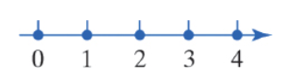
A continuous random variable

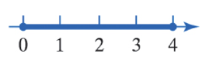

Example 1: A group of students plan to purchase a 16-ounce bag of M&M’s and record data on the contents. For each of the following variables, state whether it is discrete or continuous. State possible values for the random variable.
- Mass of each of the M&M’s

- Number of pieces of candy in the bag

- Diameter of each piece of candy

- Number of distinct colors of M&M’s in the bag

Discrete Probability Distributions
Definition: The probability distribution of a discrete random variable X

Rules for Discrete Probability Distribution:

Example 2: At insurance companies, actuaries use various data sources, tables, and models to determine various probabilities of needing to pay out certain policies. Suppose that the probability that a healthy 24-year-old will die in a given year is 0.0014. The insurance company will pay out $10,000 to the beneficiaries, but the policy costs $100 per year.

Let X be the amount of profit earned by the insurance company in a year for a 24-year-old policy holder. Create and verify the discrete probability distribution for X.

Example 3: At a monthly ‘casino night,’ there is a game called Chuck-a-Luck: Three dice are rolled in a wire cage. You place a bet on any number from 1 to 6. If any one of the three dice comes up with your number, you win the amount of your bet. (You also get your original stake back.)

If more than one die comes up with your number, you win the amount of your bet for each match. For example, if you had a $1 bet on number 5, and each of the dice came up with 5, you would win $3. There are four possible outcomes. (The selected number can match 0, 1, 2, or 3 of the dice.)

The random variable X represents the profit from a $1 bet in Chuck-A-Luck. The table below summarizes the probabilities of earning a profit of x dollars from a $1 bet. Verify that this is a discrete probability distribution.
Number of Dice Matching the Chosen Number | Profit | Probability
0 | -$1 | 0.5787
1 | $1 | 0.3472
2 | $2 | 0.0695
3 | $3 | 0.0046

- Probability distributions can also be shown via graphs. For example, with the example above:
Profit | Probability
-$1 | 0.5787
$1 | 0.3472
$2 | 0.0695
$3 | 0.0046

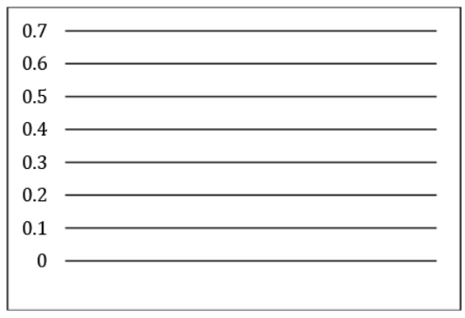

Mean of a Discrete Random Variable
Suppose we have a random variable X. What would a typical value for X be? For example, if we play the dice game, do we expect to make a profit or lose money, on average?
Definition: The mean of a discrete random variable is given by the formula:

Example 4: The random variable X represents the profit from a $1 bet in Chuck-A-Luck. The table below summarizes the probabilities of earning a profit of x dollars from a $1 bet. Compute and interpret the mean of the random variable X.

Profit | Probability
-$1 | 0.5787
$1 | 0.3472
$2 | 0.0695
$3 | 0.0046

Note: When interpreting means, it’s important to note that these averages are in the extreme long run (if you repeated this an infinite number of times!).

Definition: The mean of a random variable represents what we would expect to happen in the long run, so it is also called the expected value, or E(X). The interpretation of expected value is the same as the interpretation of the mean of a discrete random variable.

Example 5: Refer back to the insurance table. The amount of distribution of X, the amount of profit for the insurance company in a year, is shown below.
Profit | Probability
$100 | .9986
-$9900 | .0014

Find the expected value of the profit for the insurance company. Should the insurance company continue selling this policy?

Finding the Standard Deviation of a Discrete Random Variable
- The expected value finds the “average” or “typical” result of a discrete random variable, but how much will it vary from experiment to experiment?
- We can use standard deviation to explain that:

Definition: The standard deviation of a discrete random variable X is given by:

Example 6: Refer to the Chuck-A-Luck example. Computer the standard deviation of the random variable X.
Profit | Probability
-$1 | 0.0587
$1 | 0.3472
$2 | 0.0695
$3 | 0.0046

5.2 The Binomial Probability Distribution
- Certain discrete random variables all follow very similar patterns. One of these is when we want to count the number of “successes” in a number of trials, where each trial only has two results: a “success” or a “failure”.
  - For example, if you throw 10 free throws and the probability you make a free throw on any given throw is 90%, what is the probability you make 8 of the 10 free throws?
- This calculation can be tricky since we would have to list out all the ways you could get 8 successes out of 10. However, since it follows a certain pattern, we can use that pattern to make probability calculations easier.
- Definition: An experiment is said to be a binomial experiment if

Example 7: Which of the following is a binomial experiment? For any binomial experiment, identify the values of n, p, and x (the potential number of successes).
- A player rolls a pair of fair die 10 times. The number X of 7’s rolled is recorded.

- The proportion of flights that arrived on-time according to the U.S. Department of Transportation in July 2016 was 0.7515. In order to assess reasons for delays, an official with the FAA randomly selects flights from July 2016 until she finds 10 that were not on time. The number of flights X that need to be selected is recorded.

- In a class of 30 students, 55% are female. The instructor randomly selects 4 students. The number X of females selected is recorded.

Computing Binomial Probabilities
According to the Bureau of Transportation Statistics, in April, 2023 the proportion of on-time flights at Las Vegas’s McCarran International Airport was 0.70. Suppose that 4 flights are randomly selected from April, 2023 and the number of on time flights X is recorded.

Definition: Binomial Probability Distribution Function:

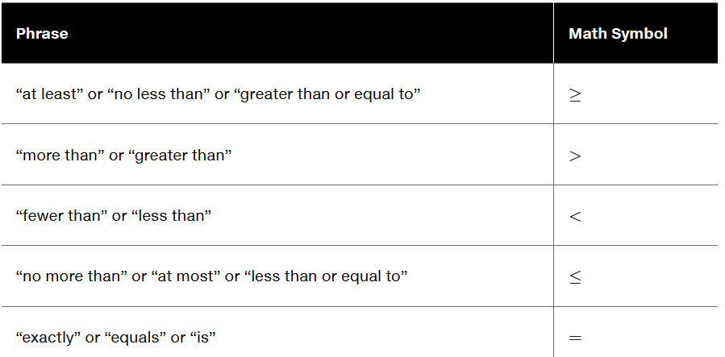

Example 8: According to CTIA, 72% of all adult Americans would rather give up chocolate than their cell phone. In a random sample of 10 adult Americans, what is the probability that
- Exactly 8 would rather give up chocolate?
- Fewer than 3 would rather give up chocolate?
- At least 3 would rather give up chocolate?

Example 9: Suppose that you are pretty good at basketball and can make a free throw 95% of the time. Suppose you throw 3 free throws.

What is the probability that:
- You make all 3 free throws?
- You make less than 3 free throws?

Mean and Standard Deviation of a Binomial Random Variable
- If a random variable follows the binomial distribution, then the mean and standard deviation both have fairly nice formulas.

Definition: A binomial experiment with n independent trials and probability of success p has a mean and standard deviation given by the formulas

Example 12: According to flightstats.com, American Airlines flights from Dallas to Chicago are on time 80% of the time. Suppose 15 flights are randomly selected, and the number of on-time flights is recorded. Find the mean and standard deviation of the number of flights of the 15 that are on time.

